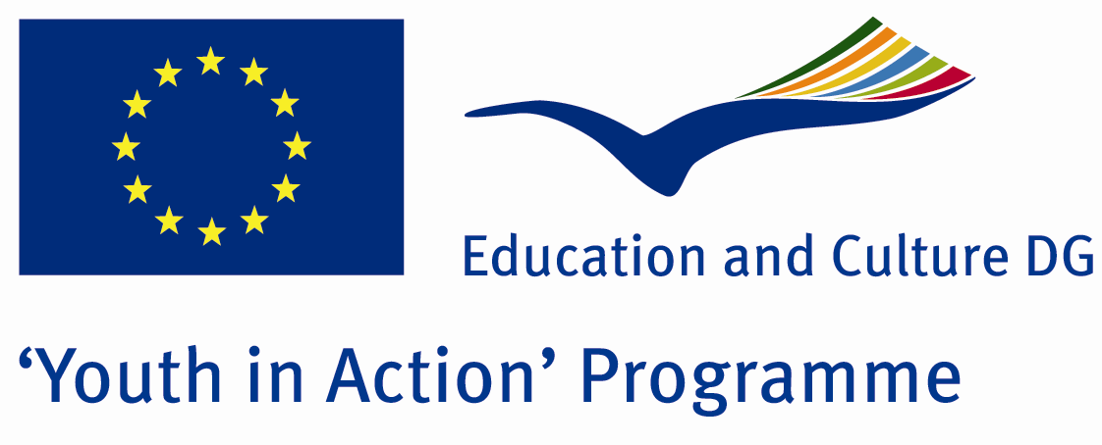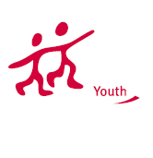

Bride of Chucky

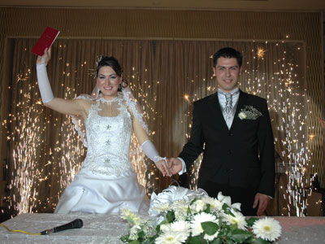

ACTION 1.1 – Youth Exchange

03-10th July , 2012

Eskişehir, TURKEY

Please contact directly to;
peaceeagles@gmail.com
Project Summary;

We will introduce our wedding ceremony in our project. We aim that we provide our guests to tell our culteral wedding ceremony. We belive that the wedding ceremony is the best day in whole life because when people undertand to find his/her soul mate, he/she starts to imagine his/her wedding ceremony and he/she wants to organize the best wedding ceremony, we think it is the same all over the world. But in this wedding ceremony has been a little diversity because of the each others culterals. Moreover we will indicate our real wedding ceremony with this project. At the end of this may be our guests invite our groups to our wedding ceremony. With this project we and our guests will learn each others culture.

Project Title; Bride of Chucky

Date and Venue ; 03-10th July , 2012 Eskişehir, Turkey .

Target Group ; Municipalities, City Councils and Non-Governmental organizations,
youth groups,culture and art groups,e.t.c

Participants ; 5 people from each country (over 18 -25 ). Totally 8 countries.

Conditions ; Accommodation, board and programme costs will be financed through European Commission Youth in Action Programme ….Travel costs will be reimbursed in 70% (APEX Tarrifs). Organizations from all 27 EU member countries plus Liechtenstein , Norway and Iceland are eligible to take part.

Working language: English

Organizer; PEACE EAGLES YOUTH, ART And SPORT GROUP

How to apply: If you are interested, please send your Part III forms to
by e-mail please please (in word file). Scan Part3 format is enough for application. (Fulfilled Part III which you can find in the attachment, of course signed and stamped) ..

If you have any questions you may contact with:
peaceeagles@gmail.com

Deadline for application; until 10th October 2011.

